SBI 4U1 Review: Atoms and Bonding Name: Dhrumil Patel
Knowledge
___
25

Multiple Choice Identify the letter of the choice that best completes the statement or
answers the question.

_a__ 1. Which statement about isotopes of the same element is correct?
a. | They have the same number of protons but different numbers of neutrons.
b. | They have the same number of electrons but different numbers of protons.
c. | They have the same number of neutrons but different numbers of protons.
d. | They have the same number of neutrons but different numbers of electrons.
e. | They have the same number of protons but different numbers of electrons.

_e__ 2. What happens to Na when it becomes Na⁺?
a. | Na loses a neutron.
b. | Na gains a proton.
c. | Na loses a proton.
d. | Na gains an electron.
e. | Na loses an electron.

_c__ 3. Which pair of elements is most likely to form an ionic bond?
a. | hydrogen and oxygen
b. | carbon and hydrogen
c. | potassium and chlorine
d. | nitrogen and hydrogen
e. | hydrogen and iodine

_b__ 4. Which statement about polar molecules is correct?
a. | They are either positively or negatively charged.
b. | They have a partial positive and partial negative charge.
c. | They have no charge.
d. | They cannot exist because molecules cannot be polar.
e. | They are neutral.

_d__ 5. Which of the following is the essential characteristic of a polar molecule?
a. | contains double or triple bonds
b. | is formed at extremely low temperatures
c. | contains ions as part of the structure
d. | has an asymmetrical distribution of electrical charge
e. | contains the element oxygen

_b__ 6. Which three of the following are characteristics of hydrogen bonds?
I. They are responsible for the surface tension properties of water.
II. They are responsible for the relatively high boiling point of water.
III. They are stronger than ionic bonds.
IV. They are present in all substances.
V. They are weaker than covalent bonds.
a. | III, IV and V | d. | II, III and IV
b. | I, II and V | e. | I, III, and IV
c. | I, III and IV

_a__ 7. Which of the following is a characteristic of ionic bonds?
a.. They are stronger than covalent bonds.
b. They are present in all substances.
c. They are responsible for the low boiling points of substances.
d. They are weaker than covalent bonds.

Fill in the Blank. Fill in the blank with the appropriate word in the space provided. (1 mark each)

a) As electrons move farther from the nucleus, their ____potential___ energy increases.

b) The electrons in the outermost s and p orbitals are called _______valence______ electrons.

c) ___Electronegativity_ is a measure of an atom's ability to attract a shared electron pair when it is participating in a covalent bond with another atom.

Short answer.

1. Draw the electron configuration for Al. (2 marks)
Al: 3s²3p¹
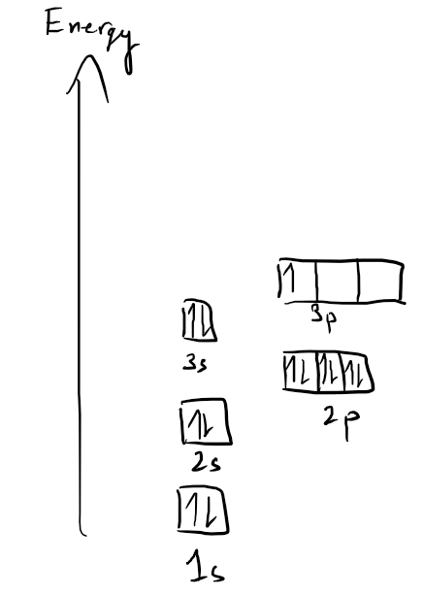
Electron Energy Level Diagram

2. For the following element ₃₁
₁₅ P

a) What is the atomic mass? (1 mark) ___31__
b) What is the atomic number? (1 mark) __15____
c) How many neutrons does this atom contain? (1 mark) ____16___
d) Draw the Bohr-Rutherford diagram of the ion. (3 marks)

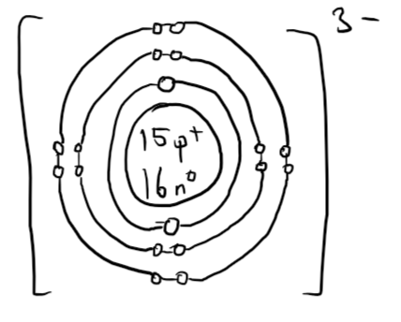

e) Draw the Lewis diagram of the atom. (2 marks)



3. Draw the Lewis diagram to show the bonds formed when the elements N (atomic number 7) and
H (atomic number 1) form a molecule. (3 marks)
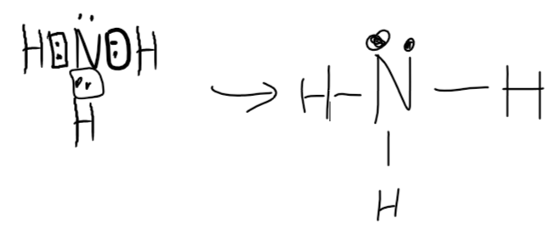
4. Why is CF₄ considered to be a nonpolar molecule? (2 marks)
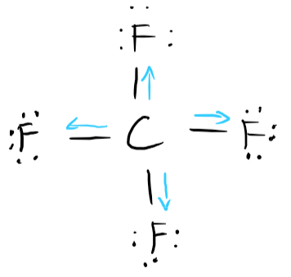
CF₄ is considered to be a nonpolar molecule because the C-F bonds are evenly distributed and cancel out in its tetrahedral shape. While the bonds are polar covalent bonds, they cancel out, leaving the molecule nonpolar and with no net dipole.

